Skateboard form (after 3 weeks) and Demo feedback
- Working prototype with minimal functionality: demonstrable, runnable build implementing core MVP features.
- Backlog implementation traceability: explicit mapping of implemented backlog items to team members (who implemented what) and commits/pull requests or timestamps.
- Definition of done (DoD) applied: documented DoD used for each completed backlog item (e.g., code compiled, unit tests passing, peer review, updated docs); evidence that DoD was met.
- Sprint demo & acceptance evidence: stakeholder acceptance notes for the sprint producing the skateboard.
Skateboard reporting form
Note your initial minimal viable prototype (MVP) can either be a 'skateboard' (complete program) or a 'wheel' (only some modules implemented). In either case the code must compile without error and run. The run need not be interactive per sé, you can read in input files and write to logs as long as an observer can clearly see what the program is doing. The skateboard code and executable must be findable on your git repo.
This prototype must meet the definition of done; i.e.: code compiles and runs without errors, unit tests with decent coverage pass. Security issues are either addressed or a plan to address them is in place.
Team details
Project name: | ViewScope
Team nickname | Swapchain
Team members (first/last name) | Adam |  |  | Kira |  |  | Azaam
Team members (first/last name) | Foflonker |  |  | Webb |  |  | Holdman
Student numbers | FFLADA001 |  |  | WBBKIR002 |  |  | HLDAZA001
Project description  1 or 2 lines | Build and interactive interface for analyzing the qualities of drone flight paths. The user interface must be responsive and easy to use. The user can inspect if a surface is observed from enough angles, often enough, close enough. The application will allow for easy visualisation of data findings. It will also allow the user to intervene in the path planning by adding/removing cameras.
Git repo url | https://gitlab.cs.uct.ac.za/swapchain/viewscope
Demo session
Fill in the blue fields prior to the demo, fill in the green fields during or shortly after the demo, make sure to assign a member to take written notes during the demo
Link to executable | Link to the executable used in this demo, make sure to capture this snapshot
Link to last commit | https://gitlab.cs.uct.ac.za/swapchain/viewscope
List of backlog items implemented | - Repo Setup & Hello World  - Early GUI implementation with VTK  - Scene rendering  - Camera Placement  - Validate Data package  - Highlight surface targets  - First-Person-View Panel (not from planning phase)  - Highlight the selected camera (not from planning phase)  - Camera Orientation Widget (not from planning phase)
Demo date | 03/09/2026
Backlog items implemented
For each implemented backlog item, copy-paste the black fields from the planning document. Do not change anything from that doc. Add implementation details in the blue fields.
Backlog item 1
Over the 3-week period a team should have 3 or more backlog items per developer.
If you have less, you may have made your items too big.
Big items need more detail than small items to score full points.
Name | Hello World
Description | Simple working application with all provided files/libraries linked.
Priority | High
Main developer | Adam
Pair programming? | 0%
Time spend | FFLADA001 |  | 100% |  | HLDAZA001 | 0% |  | WBBKIR002 | 0%
Estimated time | Half week
Acceptance criteria (DoD):
Functionality | Each member can clone the repository into their own laptop. Small test files such as a helloworld.py file may exist to ensure a secure python environment is set up. A requirements.txt file can start to be added to.
Security issues | None.
Test cases | Basic Git operations work. The `uv run viewscope` command runs the program and prints: “Hello, World from Viewscope!”
Client remarks
For implemented backlog items fill in the below fields prior to the demo
actual time | ¼ Week
Link to last git commit | https://gitlab.cs.uct.ac.za/swapchain/viewscope/-/commit/c5d9db9cb270da08cdd74505d5efb6c276bfc5f8
Commit history | Git log
Acceptance criteria | The `uv run viewscope` command runs the program and prints: “Hello, World from Viewscope!”
DoD checklist
Compile compiles | Y
Unit test coverage | All
Unit tests succeed | All
Unit tests report | Add unit test report to appendix T
Security done? | N/A
Security actions? | Describe security fixes implemented or planned
Changes made | Decided to implement CI/CD workflows here, which was not initially planned to be done in this item. Automated unit testing was also implemented as part of CI.
Backlog item 2
Name | GUI implementation with VTK
Description | The first implementation of the GUI
Priority | Middle
Main developer | Kira
Pair programming? | 10%
Time spend | WBBKIR002 |  | 85% |  | HLDAZA001 | 15% |  | FFLADA001 | 0%
Estimated time | 2 weeks
Acceptance criteria (DoD):
Functionality | Users can use two buttons that rotate left and right 90 degrees around the model and an option to switch from textured mesh to just target values along with a button that allows a screenshot or image of the window to be taken. Users can spawn cameras by clicking on a button.
Security issues | None
Test cases | Render the Kiri building and navigate 360 degrees around it.
Client remarks
For implemented backlog items fill in the below fields prior to the demo
actual time | 2 weeks
Link to last git commit
Commit history | Git log
Acceptance criteria | Full rotation around the 3D render is possible. Cameras can successfully be added to the scene and are immediately drawn in. There was no glitching or buffering initially but a commit from another member caused that to no longer be true. This will be fixed in the next sprint.
DoD checklist
Compile compiles | Y
Unit test coverage | src/viewscope/main.py 84%  src/viewscope/CameraViewport.py 97%  src/viewscope/config.py 100%  src/viewscope/data/loader.py 95%  src/viewscope/data/scene.py 100%  src/viewscope/data/store.py 90%  src/viewscope/DisplayPanel.py 100%  src/viewscope/MetricsPanel.py 99%  src/viewscope/scene.py 97%  src/viewscope/transform.py 100%  src/viewscope/viewport.py 98%  src/viewscope/window.py 97%
Unit tests succeed | Most
Unit tests report | See appendix T
Security done? | Security for the first implementation of the VTK gui included having zero user input apart from being able to traverse the 3D render. .npz files are already extensively checked through viewscope_core/. The data file path was stored in config.py and automatically loaded when users ran the application. This was an early implementation, see backlog item 5 for security features with the pyside6 GUI.
Security actions? | Planned security actions include data file validation.
Changes made | One change: No button to screen capture yet. The layout is defined and can be changed and has a reset button. The buttons to move around the scene were verbose since vtk allows users to do that with their mousepad and so the buttons were removed.
Backlog item 3
Name | Scene Rendering
Description | First fully-working implementation of scene rendering.
Priority | High
Main developer | Kira
Pair programming? | 0%
Time spend | WBBKIR002 |  | 100% |  | HLDAZA001 | 0% |  | FFLADA001 | 0%
Estimated time | 1 week (?)
Acceptance criteria (DoD):
Functionality | Correctly render the Kiri building and the frustums in the same scene.
Security issues | None, no files are passed from the user.
Test cases | Check that the orientation of the cameras match the plan.json file.
Client remarks
For implemented backlog items fill in the below fields prior to the demo
actual time | 1 day
Link to last git commit | https://gitlab.cs.uct.ac.za/swapchain/viewscope/-/commit/8bd1c7ee5bbd1df9b32ddc92bf62f93b7045fbe1
Commit history | Git log
Acceptance criteria | A single vtk frame that is responsive and renders 185+1 vtk actors, the 185 cameras plus the kiri building.
DoD checklist
Compile compiles | Y
Unit test coverage | src/viewscope/main.py 100%  This was the first main.py that was simply just a single VTK frame with the Kiri building.
Unit tests succeed | All
Unit tests report | See Appendix T.
Security done? | config.py contains the data file path so input from the user is needed.
Security actions? | Describe security fixes implemented or planned
Changes made | This did not differ from planning at all.
Backlog item 4
Name | Camera placement
Description | Implement camera picking and placement
Priority | Middle
Main developer | Adam
Pair programming? | 0%
Time spend | FFLADA001 |  | 100% |  | HLDAZA001 | 0% |  | WBBKIR002 | 0%
Estimated time | Half week
Acceptance criteria (DoD):
Functionality | Users should be able to add new cameras to the scene at x, y, z coords, pitch and yaw of their choice.
Security issues | None.
Test cases | Added cameras are visible in the viewpoints panel (shows the list of all cameras). Added cameras can be physically seen as rendered camera glyphs in the viewport.
Client remarks
For implemented backlog items fill in the below fields prior to the demo
actual time | ⅙ week
Link to last git commit | https://gitlab.cs.uct.ac.za/swapchain/viewscope/-/commit/9f441a180b79769390d3ac0590e2bb0f1bce4a1c
Commit history | Git log
Acceptance criteria | Added cameras can be “viewed from” in the camera view panel.
DoD checklist
Compile compiles | Y
Unit test coverage | None
Unit tests succeed | None
Unit tests report | Add unit test report to appendix T
Security done? | N/A
Security actions? | Describe security fixes implemented or planned
Changes made | The codebase required a moderate refactor before being able to implement the required functionality.
Backlog item 5
Name | VTK implementation
Description | Implement relevant VTK gizmos & visualizations
Priority | Middle
Main developer | Kira
Pair programming? | 0% - 100% in ~10% increments
Time spend | WBBKIR002 |  | 90% |  | HLDAZA001 | 5% |  | FFLADA001 | 5%
Estimated time | 1 Week
Acceptance criteria (DoD):
Functionality | Implementing & initializing VTK and ensuring all required visualization methods, tools and other gizmos are working and available for use.
Security issues | Describe security problems
Test cases | Visual inspection of the tools/gizmos and control over them via mouse+keyboard inputs.
Client remarks
For implemented backlog items fill in the below fields prior to the demo
actual time | in weeks or fractions of weeks
Link to last git commit | https://gitlab.cs.uct.ac.za/swapchain/viewscope/-/commit/2ffb05a20c9da5c29012fb806ab0f6f11f467c22
Commit history | VTK implementation (no git log)
Acceptance criteria | A working GUI with interactive dockable panels. One for the central VTK frame, a vtk frame for camera views, a metrics panel and a panel that lists all cameras and their ids.
DoD checklist
Compile compiles | Y
Unit test coverage | src/viewscope/CameraViewport.py 97%  src/viewscope/config.py 100%  src/viewscope/data/loader.py 95%  src/viewscope/data/scene.py 100%  src/viewscope/DisplayPanel.py 100%  src/viewscope/main.py 84%  src/viewscope/MetricsPanel.py 99%  src/viewscope/panels/viewpoints_panel.py 99%  src/viewscope/scene.py 97%  src/viewscope/transform.py 100%  src/viewscope/viewport.py 98%  src/viewscope/window.py 97%
Unit tests succeed | Most
Unit tests report | See appendix T
Security done? | viewscope_core/loaders.py checks plan.json and rejects non-finite positions.viewscope_core is very thorough with error handling and incorrect inputs. No network security implemented since this is a single-use desktop application that does not interact with the internet. There are no user-supplied file paths. config.py stores all file input values such as ‘DATA_DIR’.
Security actions? | No authentication, authorisation or session handling implemented because this is open source software that we provide to the client. We trust the client to use this as a single-user offline desktop viewer. Further security actions may be discussed during the demo on 1/09/2026
Changes made | Describe briefly how implementation differs from planning
Backlog item 6
Name | Load and validate the data package
Description | As a user, I want to know whether the assets I’m loading are valid, so that I know whether to continue the application or be required to load new data.  Through the library loaders, failing to open a file will be closed with an actionable message on any malformed file rather than continuing with partial data.
Priority | Middle
Main developer | Azaam
Pair programming? | 0%
Time spend | HLDAZA001 |  | 90% |  | WBBKIR002 | 10% |  | FFLADA001 | 0%
Estimated time | 1/7 week
Acceptance criteria (DoD):
Functionality | Attempting to open a corrupted file will result in an error message and not crash the program. Attempting to display a textured model where no texture is provided will result in an un-textured model. Attempting to open an incompatible file type will result in the appropriate error message.
Security issues | Users can reveal their folder structure in an absolute path (e.g. Documents>PersonalStuff>Viewscope) after clicking the “open folder” button from an error dialog.
Test cases | Open a corrupted file, open a file that is incompatible with the software such as an html file, remove textures from the objects folder and try to render it with texture.
Client remarks
For implemented backlog items fill in the below fields prior to the demo
actual time | 4/7 week
Link to last git commit | https://gitlab.cs.uct.ac.za/swapchain/viewscope/-/commit/30d6fdec1f008f9734b20680bd4b89a06fe09071
Commit history | Git log
Acceptance criteria | Attempting to open an invalid Data file will prompt a Dialog window to open. That error dialog window will contain an error message, an actionable message, and a button to safely close the application.  Added:  - checking if Plan.json has a minimum of 185 viewpoints before loading all assets.  - Missing required files will be communicated to the user via a dialog window.
DoD checklist
Compile compiles | Y
Unit test coverage | All
Unit tests succeed | All
Unit tests report | Appendix T
Security done? | N. This involves accessing the user’s folders, but I haven’t implemented a way to block out the user’s folder structure. It’s revealed right now.
Security actions? | The Data folder opens by default, when the user clicks “Open folder location" on the error dialog.  Used try-catch blocks around file operations and file loading, to prevent application crashes.  Implemented cross-platform folder opening.
Changes made | All the opening of files happens from source code. We’re currently not supporting the dynamic loading of selected files from a file dialog.  The only opening of folders occurs when an invalid file is loaded and an error dialog is displayed with a button to open the `Data` folder.  When deleting the textures from Data/kiri/Mesh, the scene still rendered a model with textures. So we dropped that from our original functionality criteria.
Backlog item 11
Name | Highlight the visible surface targets of a selected camera.
Description | Highlight the visible surface targets of the selected camera in the 3D scene, so the user can see at a glance what that camera covers. Occluded targets must never be highlighted. This will include changing the colour of targets that are in the view of said selected camera.
Priority | High
Main developer | Kira
Pair programming? | 0%
Time spend | WBBKIR002 |  | 100% |  | HLDAZA001 | 0% |  | FFLADA001 | 0%
Estimated time | 2 weeks
Acceptance criteria (DoD):
Functionality | Select a camera and observe which targets are in the camera's view. Highlight targets that the camera can see. Allow the user to rotate the model to observe all targets, both highlighted and non-highlighted.
Security issues | Input from the user is limited to a single button called “view occlusion.”
Test cases | Ask if it logically makes sense for that camera to be able to see those targets. Check correctness against all the highlighted targets and the (target, camera) pairs.
Client remarks
For implemented backlog items fill in the below fields prior to the demo
actual time | in weeks or fractions of weeks
Link to last git commit | https://gitlab.cs.uct.ac.za/swapchain/viewscope/-/commit/794964e8c075bf7cf407beb27a1e4d4b7681eeb9
Commit history | Gt log
Acceptance criteria | The targets that a selected camera can see are painted red. Occluded targets should all be grey. A camera should not be able to see a target that is on the other side the the building.
DoD checklist
Compile compiles | Y
Unit test coverage | src/viewscope/highlight_targets.py 100%  src/viewscope/main.py 84%  src/viewscope/viewport.py 98%  src/viewscope/window.py 97%
Unit tests succeed | Most
Unit tests report | See appendix T
Security done? | Restricted user input
Security actions? | Planned security actions include limiting the amount of times a user can click a button to prevent cache overflow.
Changes made | No changes.
GenAI declaration
Did you use GenAI | Y
Describe use | Describe the nature and extent of GenAI use and the specific model used. Briefly detail GenAI use for each implemented backlog item. You are allowed to use GenAI, but you must adhere to the GenAI policy shown on the CSC3003S Amathuba site.  Azaam: Yes. Both Claude(Sonnet 5) and Deepseek(Instant) were used. I used them to help improve my understanding of the VTK and PySide 6 libraries while researching. Alongside looking at official documentation for both libraries, I used Claude to help me configure Pyside6 widgets and help structure the layout of the GUI panels.  Within code, I used them to generate boilerplate code(file processing) and to help me debug issues that I struggled debugging myself.  - Load and validate data package:  I used Claude to help generate boilerplate for the reading of JSON files and searching for specific values. Also used it to implement cross-platform folder opening.  Adam: Yes. GPT 5.6 Luna. Used to help implement the mouse events in viewport.py, enabling infinite mouse manipulation in the viewport. Also used AI to help me in using the numpy library. Also used to help in the implementation of various GUI elements in PySide6 and QtWidgets.  Kira: Yes. Claude(Opus 5) was used. I used Claude to help set up pyside6. It generated one large main file. I split this python file into OOP design specifically so each group member could work on a class/panel of the ui in a way that was isolated and would avoid merger conflicts. This worked well. Each group member was in charge of their panels and could individually decide how to implement their features. I did the debugging myself. I used Claude to generate unit tests such that it would cover over 80% of all files. Total unit test coverage is 97%.
No diagrams requested nor provided.
Add any citations as needed

Appendix C.
Hello World | commit c5d9db9cb270da08cdd74505d5efb6c276bfc5f8  Author: Adam Foflonker <87928802+DnA-IntRicate@users.noreply.github.com>  Date: Sat Aug 8 11:40:02 2026 +0200  Feat: CI testing & code analysis (#3)  * Add pytest & pytest-cov deps  * Create python-test.yml workflow  * Pytest examples  * CI switch tot setup-uv action with immutable release tag  * CI verify package integrity via uv build  * Implement the ty typechecker  * Create root-level tests folder  * Configure pytest-cov with an 80% threshold  * Write test_main.py  * ty.toml: Remove excludes and add tests dir to src  * Fix ty.toml  * Fix python-test.yml system deps (I hope)  * python-test.yml: Enable lfs for checkout  * Fix python-test.yml (again)  * Ignore .ruff_cache/ dir  * CI: Set python-version to 3.14  * python-test.yml: Remove package build step  commit 2aac341c17e61a7e7ca1499e3cca65a8de9937c5  Author: Adam Foflonker <87928802+DnA-IntRicate@users.noreply.github.com>  Date: Sat Aug 8 09:04:14 2026 +0200  Feat: CI Python code linting (#2)  * Create python-lint.yml workflow  * Rewrite Ruff settings into .ruff.toml  * Run ruff linter & formatter  * .ruff.toml: Remove trailing slash on 'src/viewscope_core' exclude  * python-lint.yml: Add .ruff.toml to paths  commit 187061b794639825371eb88015019b82815e32c0  Author: Adam Foflonker <87928802+DnA-IntRicate@users.noreply.github.com>  Date: Fri Aug 7 20:11:25 2026 +0200  Chore: Migrate from GitLab to GitHub (#1)  Add project files  commit 960e37541fd299afa1ccf65a6a2a012b199a1757  Author: Adam Foflonker <87928802+DnA-IntRicate@users.noreply.github.com>  Date: Fri Aug 7 11:35:30 2026 +0200  Initialize git lfs
GUI implementation with VTK | commit 8bd1c7ee5bbd1df9b32ddc92bf62f93b7045fbe1  Author: Schmebb <kira@webbs.co.za>  Date: Tue Aug 25 14:57:44 2026 +0200  Feat: GUI implementaion with VTK (#6)  * basic files for compilation in pyside6  * redundant files removed, web gui added. run: uv run python scripts/export_web_bundle.py  * readme updated  * readme formatting  * refactor: split monolith code into OOP design. DisplayPanel.py, CameraFlippingPanel.py and MetricsPanel.py added  * refactor: removed redundant classes  * refactor: remove main_vtk.py  * docs: updated README  * docs: added comments  * feat: working camera-flipping side panel  * Fix linting issues & remove vs_gui.py  * Move variables.md to docs/ dir  * Fix type-checker issues  * Temp disable python-test workflow  * Delete web/ dir  * Delete other unused files  * Amend to previous  ---------  Co-authored-by: Kira Webb <kirawebb@Mac.lan>  Co-authored-by: Kira Webb <kirawebb@9e-10-6c-78-bd-df.lan.uct.ac.za>  Co-authored-by: Adam Foflonker <87928802+DnA-IntRicate@users.noreply.github.com>  commit 1c87a69f4b5c69cf5b994c4cb0e190a8273f28dc  Author: Adam Foflonker <87928802+DnA-IntRicate@users.noreply.github.com>  Date: Mon Aug 10 08:34:25 2026 +0200  Docs: Complete assignment 1 document (#4)  Complete assignment 1 document
Scene Rendering | (Was implemented in the previous item)
Camera Placement | commit 9f441a180b79769390d3ac0590e2bb0f1bce4a1c  Author: Adam Foflonker <87928802+DnA-IntRicate@users.noreply.github.com>  Date: Sat Aug 29 09:34:38 2026 +0200  Feat: Camera Placement (#8)  * CameraFlippingPanel: Create "Add Camera" button  * Move Linux env config to main  * Rename CameraFlippingPanel -> ViewpointsPanel  * Replace all dot-imports with 'viewscope' package name  * Rework vtk/qt/pyside6 config into bootstrap module qt.py  Did this to eliminate redundancy and get rid of some of the ruff noqa comments.  * Create addcamera_dialog  * Split loading.py into separate modules implemented in viewscope.data  * Working add_camera fn & ViewpointsPanel refresh fn  We should probably consider adding all user-created cameras to a new vc.Plan called new_plan - instead of adding it to the current plan.  * Split camera, fix MetricsPanel, rm count from CameraInfo  * Update viewports & draw camera glyphs  * Run ruff format & check  * Fix ty issues

VTK Implementation
Validate data package | C:\Users\Azaam\Documents\GitHub\viewscope>git log  commit 3f72fafbb9e757760018997cb886c3b792d75e8b (HEAD -> feat/load-validate-data-package, origin/feat/load-validate-data-package)  Author: Azaam <53663013+aZaamBie@users.noreply.github.com>  Date: Mon Aug 31 10:52:22 2026 +0200  Added return for successful check within validate_required_files()  I recieved this error (TypeError: cant unpack non-iterable NoneType object) bevcause I forgot to add a return "True" for successful checks, within the validate_required_files() method.  commit ca3267c1702d609dff2106e2a7b0bb7e13f7a219  Author: Azaam <53663013+aZaamBie@users.noreply.github.com>  Date: Mon Aug 31 10:46:37 2026 +0200  Applied linting and ruff checks  commit ddebb280085e4c849da897a50cdc9c9f423afe6b  Author: Azaam <53663013+aZaamBie@users.noreply.github.com>  Date: Mon Aug 31 10:39:54 2026 +0200  Display the missing files to User  commit 756a9caca61cedd160c4802f0039d932c61939bf  Author: Azaam <53663013+aZaamBie@users.noreply.github.com>  Date: Mon Aug 31 10:02:05 2026 +0200  Emit validation error from Scene Loader + Show dialog from MainWindow  commit c18c163c2fc7f416e3f6fc065e99764a71cad8fe  Author: Azaam <53663013+aZaamBie@users.noreply.github.com>  Date: Mon Aug 31 10:01:12 2026 +0200  Error Dialog class created  This Dialog show's the error, an actionable message, and two buttons: one for opening the folder, and one for exiting application  commit fae9fc7487619e77a63993e6a4b8662c76226884  Author: Azaam <53663013+aZaamBie@users.noreply.github.com>  Date: Mon Aug 31 09:13:04 2026 +0200  Count the viewpoints within plan.json  commit d4b08c7a7973079ca8a9c12d9cf2e629ab1201be  Author: Azaam <53663013+aZaamBie@users.noreply.github.com>  Date: Sun Aug 30 18:00:34 2026 +0200  quick syntax fix "is not" -> "!="  commit d2ccfa54f744d06939f1bd57602828e6f720e8e7  Author: Azaam <53663013+aZaamBie@users.noreply.github.com>  Date: Sun Aug 30 17:41:13 2026 +0200  Logging messags to terminal  commit c9b65200a705f95b2086d582af7fd182406b466d  Author: Azaam <53663013+aZaamBie@users.noreply.github.com>  Date: Sat Aug 29 10:05:50 2026 +0200  Created new file + class
Highlight surface target | commit 794964e8c075bf7cf407beb27a1e4d4b7681eeb9  Author: Schmebb <kira@webbs.co.za>  Date: Sun Aug 30 15:44:52 2026 +0200  Feat/highlight targets (#14)  * hightlight_targets.py added  * class TargetVisibility added in highlight_taregts.py. dict _cache acts as a cash for loaded target values  ---------  Co-authored-by: Kira Webb <kirawebb@Mac.lan>  commit b76ce508cd5b7fa7d07901e82572e80d9f9a5886  Author: aZamBie <53663013+aZaamBie@users.noreply.github.com>  Date: Sun Aug 30 12:25:54 2026 +0200  Feat: highlight selected camera (#13)  * Logging the selected camera's position  * CameraOutline class created  * Set local selected camera position + draw outline from viewport  * Remove previous outline  The outlines weren't being cleared, and were building up on the screen. Now i'm calling the remove() method from outline class, to clear all outlines before spawning the selected camera's outline.  * Small clean up in scene and viewport script  viewport:  - Removed the highlight camera method  - Removed unnecessary comments  scene.py:  - improved docstring  * Store camera position before building the outline  I fixed a design flaw where the highlighted camera was actually the previously selected and not currently selected camera. I messed up the order of operations there.  The set_selected_camera_position() method was called after viewports _on_camera_changed() method, which drew the outline.  My fix: storing the position of camera before drawing the outline.  * Improving clarity in docstring for CameraOutline  * Applied the UV linting fixes  * Applied UV ruff check fix  I replaced "!=" with "is not"

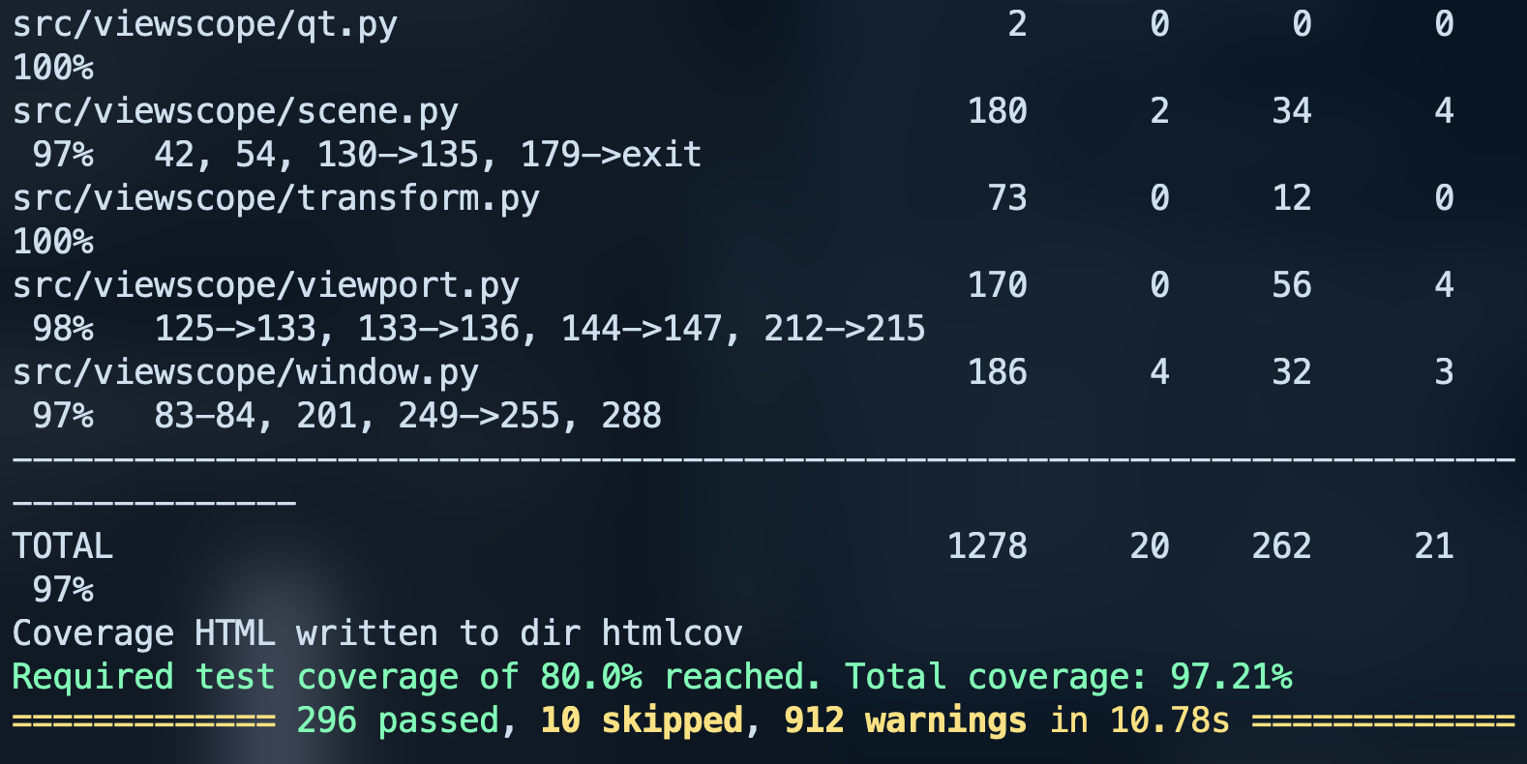
Appendix T.

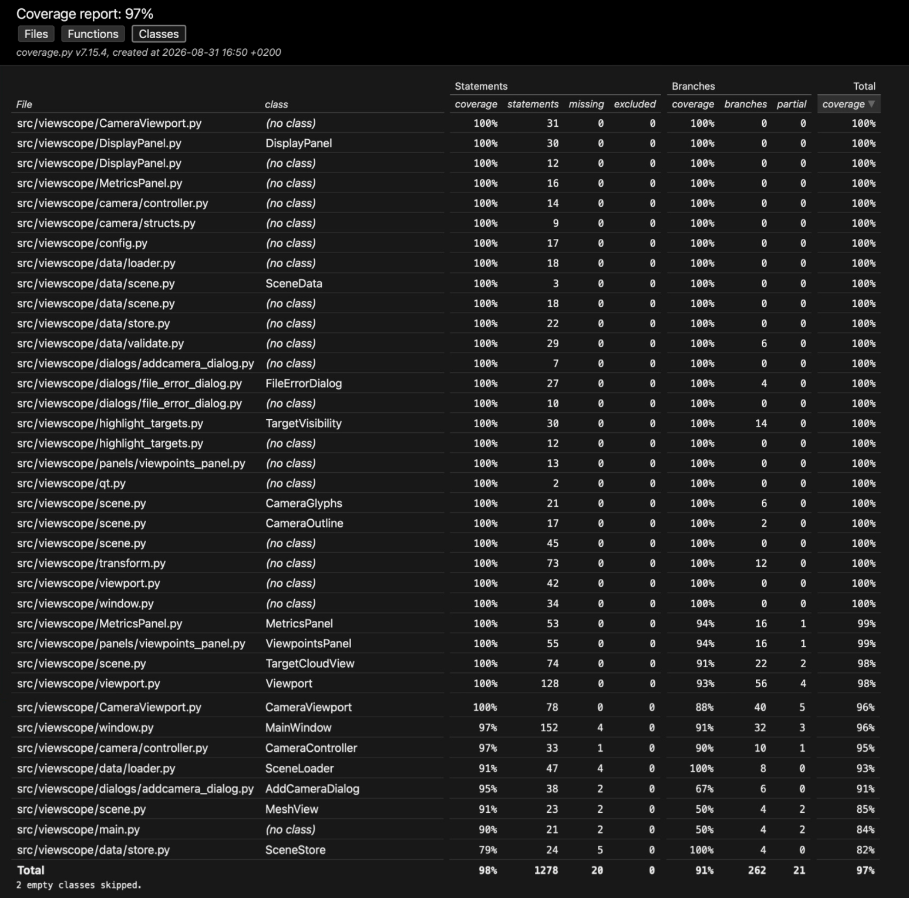

See viewscope/htmlcov/class_index.html after running ‘uv run pytest’
Other comments:

